Rocket Main
Rocket Helper
DrawFullRocket
DrawRocket
DrawEnd

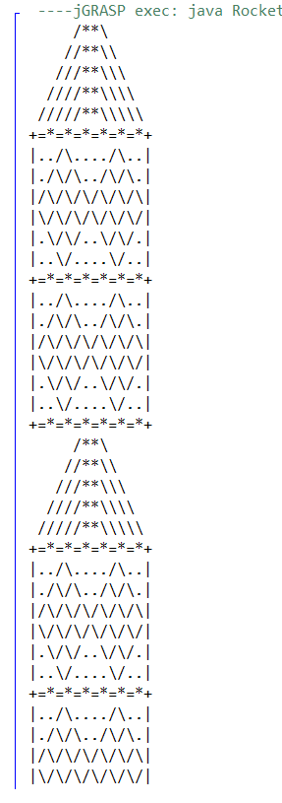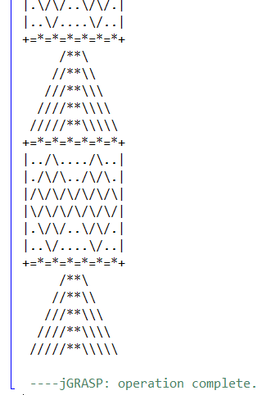
(The full output couldn’t fit on my screen so I cut it in half)

0. RocketHelper
- Main
- Call the output for the whole rocket

2. DrawRocket
- Draws the first two sections of the rocket

3. DrawEnd
- Draws the final section of the rocket

4. DrawFullRocket
- Combines the previous two methods and draws the full rocket

0. RocketMain
- Main
- RocketHelper.DrawFullRocket calls the method from the helper file to create the rocket in the main file

